MarkingSemester One Examination, 2019

Question/Answer booklet

MATHEMATICS SPECIALIST
UNIT 3

Section One:

Calculator-free

Your Name

Your Teacher’s Name

Time allowed for this section
Reading time before commencing work: five minutes
Working time: fifty minutes

Materials required/recommended for this section
To be provided by the supervisor
This Question/Answer booklet
Formula sheet

To be provided by the candidate
Standard items: pens (blue/black preferred), pencils (including coloured), sharpener, correction fluid/tape, eraser, ruler, highlighters

Special items: nil

Important note to candidates
No other items may be taken into the examination room. It is your responsibility to ensure that you do not have any unauthorised material. If you have any unauthorised material with you, hand it to the supervisor before reading any further.

Structure of this paper

Section | Number of questions available | Number of questions to be answered | Working time (minutes) | Marks available | Percentage of examination
Section One:  Calculator-free | 7 | 7 | 50 | 49 | 34.5
Section Two:  Calculator-assumed | 13 | 13 | 100 | 93 | 65.5
 |  |  |  | Total | 100

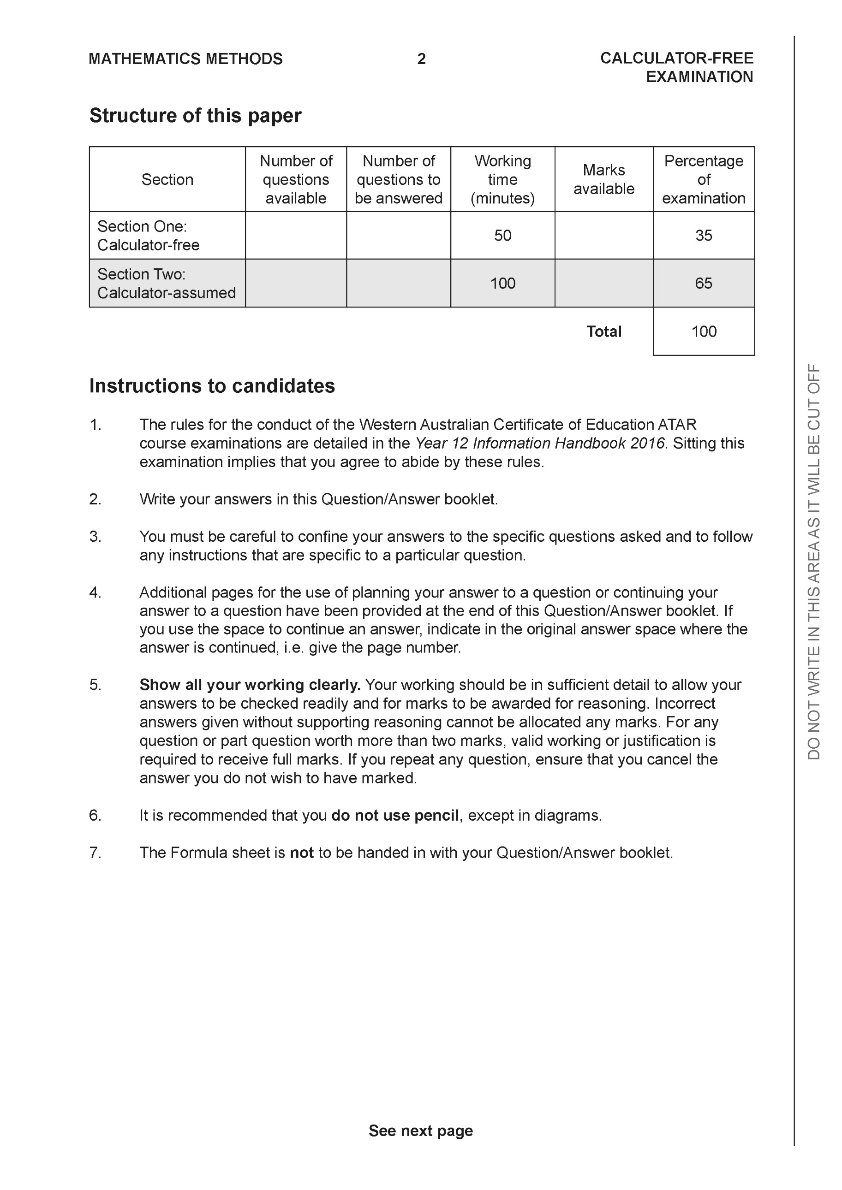

Section One: Calculator-free (49 Marks)

This section has seven (7) questions. Answer all questions. Write your answers in the spaces provided.

Spare pages are included at the end of this booklet. They can be used for planning your responses and/or as additional space if required to continue an answer.
● Planning: If you use the spare pages for planning, indicate this clearly at the top of the page.
● Continuing an answer: If you need to use the space to continue an answer, indicate in the original answer space where the answer is continued, i.e. give the page number. Fill in the number of the question that you are continuing to answer at the top of the page.

Working time: 50 minutes.

Question 1 (8 marks)

Let and .
- Determine (2 marks)

Solution
Specific behaviours
subs g into g
simplifies expression

- Does exist over the natural domain of ? Explain. (2 marks)

Solution
Specific behaviours
states range and domain
states not exist

- Determine (simplify) and its natural domain. (4 marks)

Solution
Specific behaviours
subs g into f
simplify expression
lower limit of domain (excluded)
upper limit of domain (included)

Question 2 (4 marks)

Let where are real constants. Determine all possible value(s) of .

Solution
Specific behaviours
multiplies both sides by denominator
obtains two simultaneous eqns
obtains quadratic eqn for one variable
obtains two pairs of values

Question 3 (6 marks)

Solve for in the following system of linear equations.
Solution
Specific behaviours
eliminates one variable from one equation
eliminates one variable from two equations
eliminates two variables from one equation
solves for one variable
solves for two variables
solves all three variables
NOTE: No need to use gaussian elimination method

Question 4 (6 marks)
Sketch the following function on the axes below showing all major features.

Solution

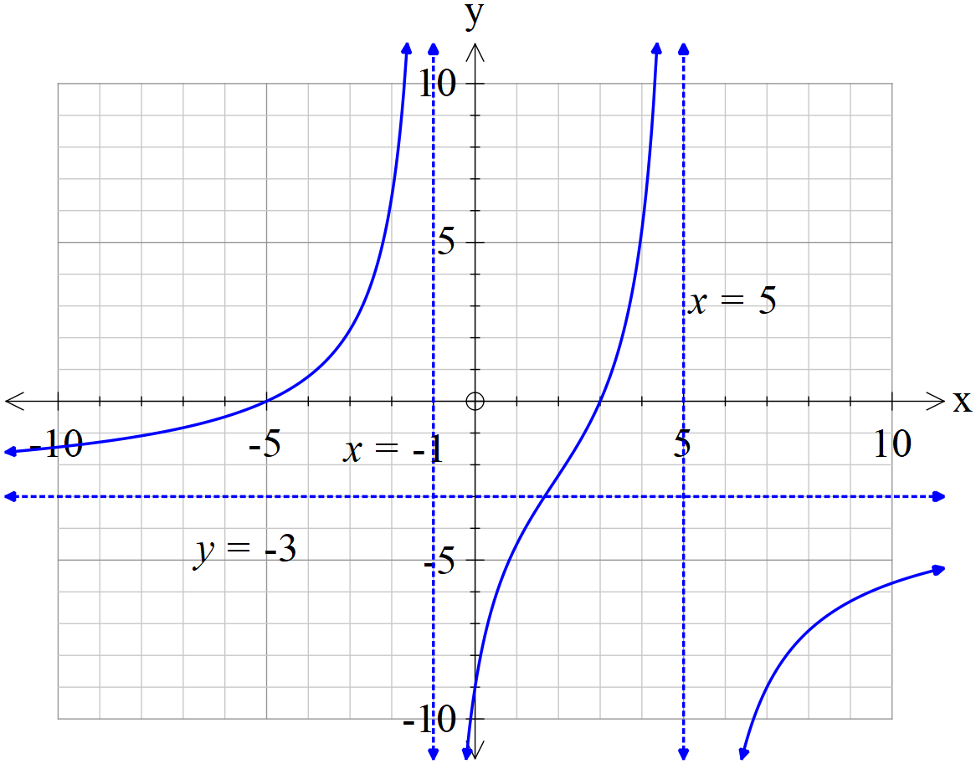

Specific behaviours
shows dotted lines for both vertical asymptotes
shows dotted line for horizontal asymptote for far left and right
labels equation of all 3 asymptotes
shows y intercept
correct shape in 2 sections
correct shape in all 3 sections

Question 5 (9 marks)

- Determine all roots of in exact polar form with principal arguments.
(4 marks)

Solution
Specific behaviours
determines modulus(no need to simplify)
uses De Moivre’s Theorem to find one argument
determines three principal arguments(no need to simplify)
determines all six principal arguments(no need to simplify)

- Plot all of these roots on the graph below showing all major features. (2 marks)

Solution

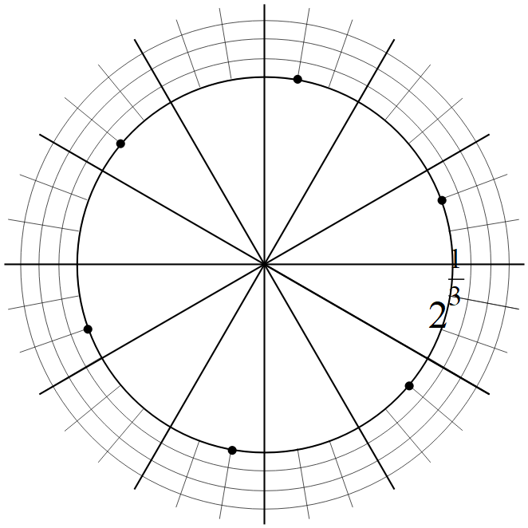

Specific behaviours
shows scale
six points equally spaced and positioned correctly

- If all the consecutive roots are joined by a straight line, determine the exact area of the polygon formed. (3 marks)

Solution

6 equilateral triangles

Specific behaviours
uses equilateral triangles
determines area of one triangle
determines simplified exact area in total

Question 6 (7 marks)

Determine all solutions of the following equations.
- and express in exact polar form with principal arguments.
(4 marks)

Solution
Specific behaviours
uses quadratic formula to express in two polar forms
uses De Moivre’s to square root
obtains two roots in polar principle arguments
obtains the conjugates of these roots

- and express in exact cartesian form. (3 marks)

Solution
Specific behaviours
uses quadratic formula
expresses discriminant in polar form
obtains two roots in exact cartesian form

Question 7 (9 marks)
A, B & C are 3 distinct points with non-zero position vectors respectively.

- If what can be deduced about and ? Explain. (3 marks)

Solution
Specific behaviours
uses distributive law
shows AB cross c is zero
states parallel

- If what relationship exists between ? (3 marks)

Solution
Specific behaviours
express c in terms of a & b
expands b cross c in terms of a & b
shows pairs are equal

- If and , prove that for some scalar . (3 marks)
Solution
Specific behaviours
uses distributive law
negative used when changing order of cross
shows parallel

Additional working space
Question number:

Additional working space
Question number:

Additional working space
Question number:

Acknowledgements

